**Project Design Phase-II**

**Data Flow Diagram & User Stories**

|  |  |
| --- | --- |
| Date | 12 November 2022 |
| Team ID | PNT2022TMID50737 |
| Project Name | Inventory Management System For Retailers |
| Maximum Marks | 4 Marks |

**Data Flow Diagrams:**

A Data Flow Diagram (DFD) is a traditional visual representation of the information flows within a system. A neat and clear DFD can depict the right amount of the system requirement graphically. It shows how data enters and leaves the system, what changes the information, and where data is stored.

**Example: Dataflow**

User

Web UI

Seeing Items

Search Items

Purchase Items

Pay the amount

Receive mail notify

**INVENTORY MANAGEMENT SYSTEM FOR RETAILERS:**

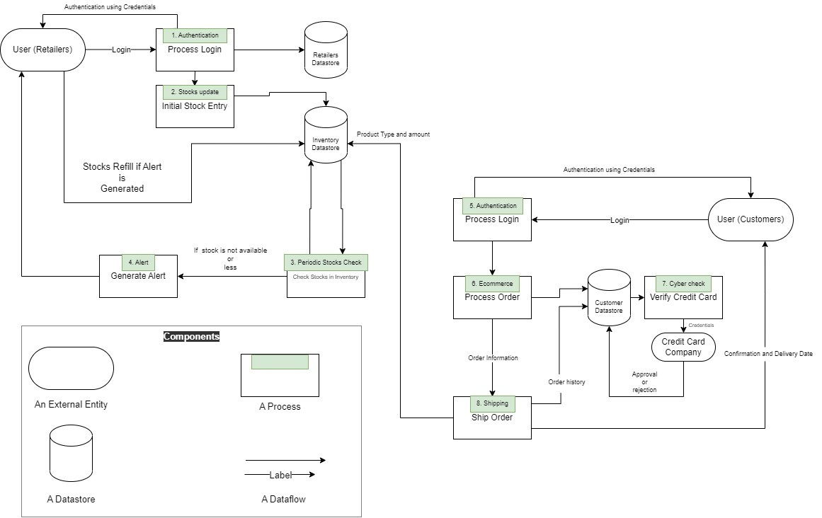

**User Stories**

List of all the user stories for the product.

|  |  |  |  |  |  |  |
| --- | --- | --- | --- | --- | --- | --- |
| **User Type** | **Functional**  **Requirement (Epic)** | **User Story**  **Number** | **User Story / Task** | **Acceptance criteria** | **Priority** | **Release** |
| Retailer | Registration | USN-1 | As a user, I can register for the application by entering my email, password, and confirming my password. | I can access my account / dashboard | High | Sprint-1 |
|  |  | USN-2 | As a user, I will receive confirmation email once I have registered for the application | I can receive confirmation email & click confirm | High | Sprint-1 |
|  |  | USN-3 | As a user, I can register for the application through Facebook | I can register & access the dashboard with Facebook Login | Low | Sprint-3 |
|  |  | USN-4 | As a user, I can register for the application through Gmail | I can register and access dashboard | Medium | Sprint-1 |
|  | Login | USN-5 | As a user, I can log into the application by entering email & password | Successful login into the application | High | Sprint-1 |
|  |  | USN-4 | As a user, I can login into the application through Google one Tap Sign in | I can login and access the dashboard with Google One Tap Login | Medium | Sprint-2 |
|  | Dashboard | USN-5 | As a user, I must be able to see my details on the dashboard. | I can see the profile details. | High | Sprint-1 |
|  |  | USN-6 | As a user, I should be able to change password whenever I prefer. | I can see change password feature on the dashboard. | Medium | Sprint-2 |
|  | Inventory | USN-7 | As a retailer, I should be able to alter product details in the app | Successful edit of product details | High | Sprint-1 |
|  |  | USN-8 | As a retailer, I should be able to add or remove quantity of products in the app. | Successful edit of product quantity | High | Sprint-1 |
|  |  | USN-9 | As a retailer, I should get alert on stock shortage or unavailability. | Successful alert generation | Medium | Sprint-2 |
| Customer (End user) | Registration | USN-1 | As a user, I can register for the application by entering my email, password, and confirming my password. | I can access my account / dashboard | High | Sprint-1 |
|  |  | USN-2 | As a user, I will receive confirmation email once I have registered for the application | I can receive confirmation email & click confirm | High | Sprint-1 |
| **User Type** | **Functional**  **Requirement (Epic)** | **User Story**  **Number** | **User Story / Task** | **Acceptance criteria** | **Priority** | **Release** |
|  |  | USN-3 | As a user, I can register for the application through Facebook | I can register & access the dashboard with Facebook Login | Low | Sprint-3 |
|  |  | USN-4 | As a user, I can register for the application through Gmail | I can register and access dashboard | Medium | Sprint-1 |
|  | Login | USN-5 | As a user, I can log into the application by entering email & password | Successful login into the application | High | Sprint-1 |
|  |  | USN-4 | As a user, I can login into the application through Google one Tap Sign in | I can login and access the dashboard with Google One Tap Login | Medium | Sprint-2 |
|  | Dashboard | USN-5 | As a user, I must be able to see my details on the dashboard. | I can see the profile details. | High | Sprint-1 |
|  |  | USN-6 | As a user, I should be able to change password whenever I prefer. | I can see change password feature on the dashboard. | Medium | Sprint-2 |
|  | Order | USN-7 | As a user, I should be able to order items on the app | Successful order placement | High | Sprint-1 |
|  |  | USN-8 | As a user, I should be able to verify and pay in a secure payment gateway | Integration of secure payment gateway | High | Sprint-1 |
|  |  | USN-9 | As a user, I should be able to get the product on time. | Product delivery on time | Medium | Sprint-1 |
| Administrator | Maintenance | USN-1 | As a administrator, I should be able to edit details of the users of the app. | Successful access privileges granted | High | Sprint-1 |
|  |  | USN-2 | Termination user accounts temporarily or permanently if needed. | Termination of user account. | Medium | Sprint-2 |
| Customer Care | Feedback | USN-1 | As a customer care team member, I should be able to get feedback from the users. | User feedbacks | Medium | Sprint-3 |
|  |  | USN-2 | As a customer care team member, I should be available 24/7 to increase customer base | Integration of Chatbot which can work 24/7 | Low | Sprint-3 |